MongoDB Setup

Download mongodb community server

<https://www.mongodb.com/try/download/community>

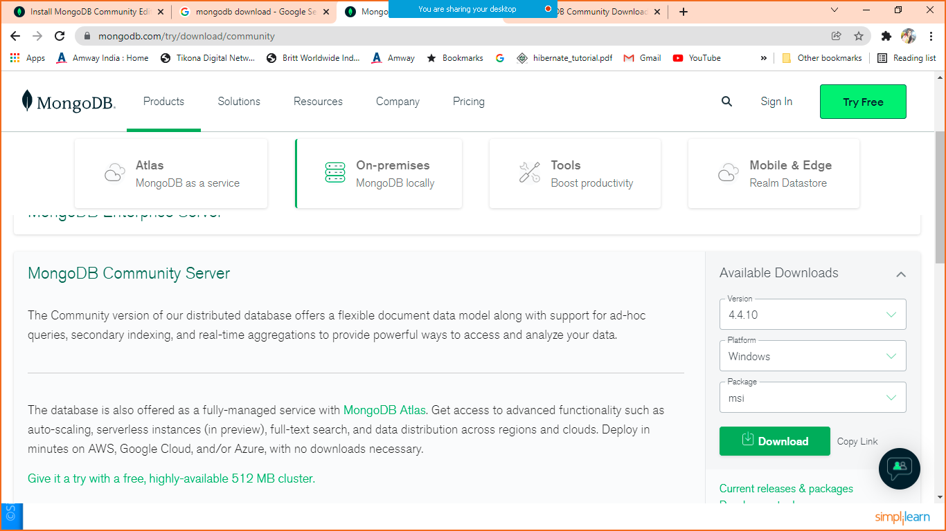

Select appropriate version, OS and .msi file for download

Install the .msi file by double clicking on that.

Once it is installed you can see MongoDB folder in your programFiles

C:\Program Files\MongoDB\Server\4.4

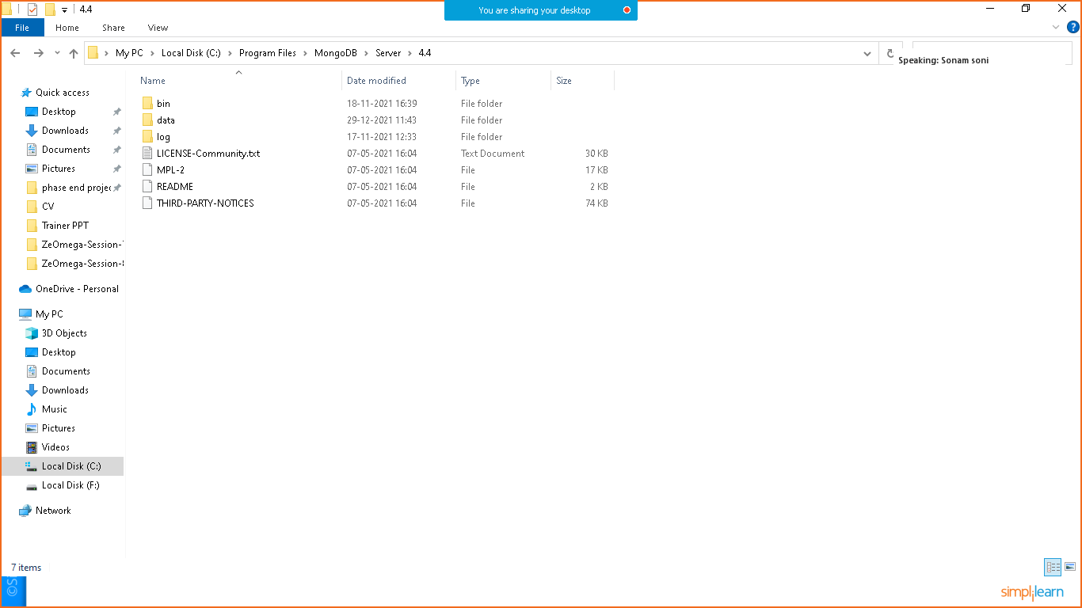

You can open bin folder

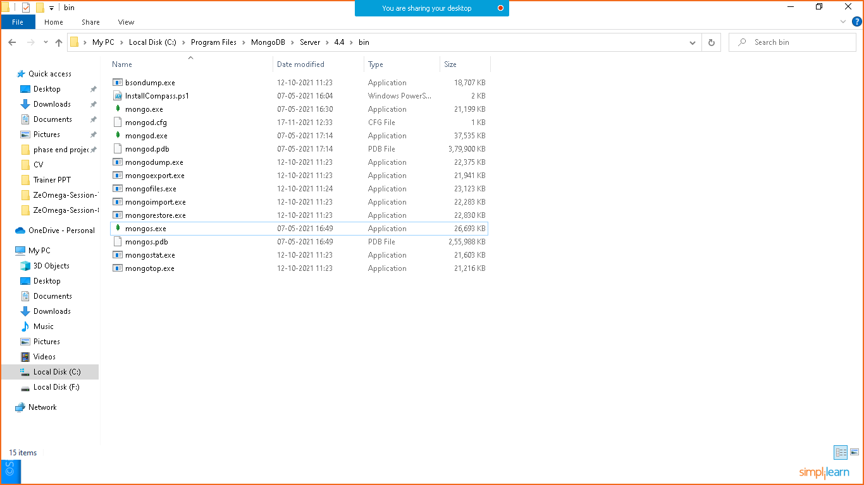

Click on mongo.exe to directly open mongo shell.

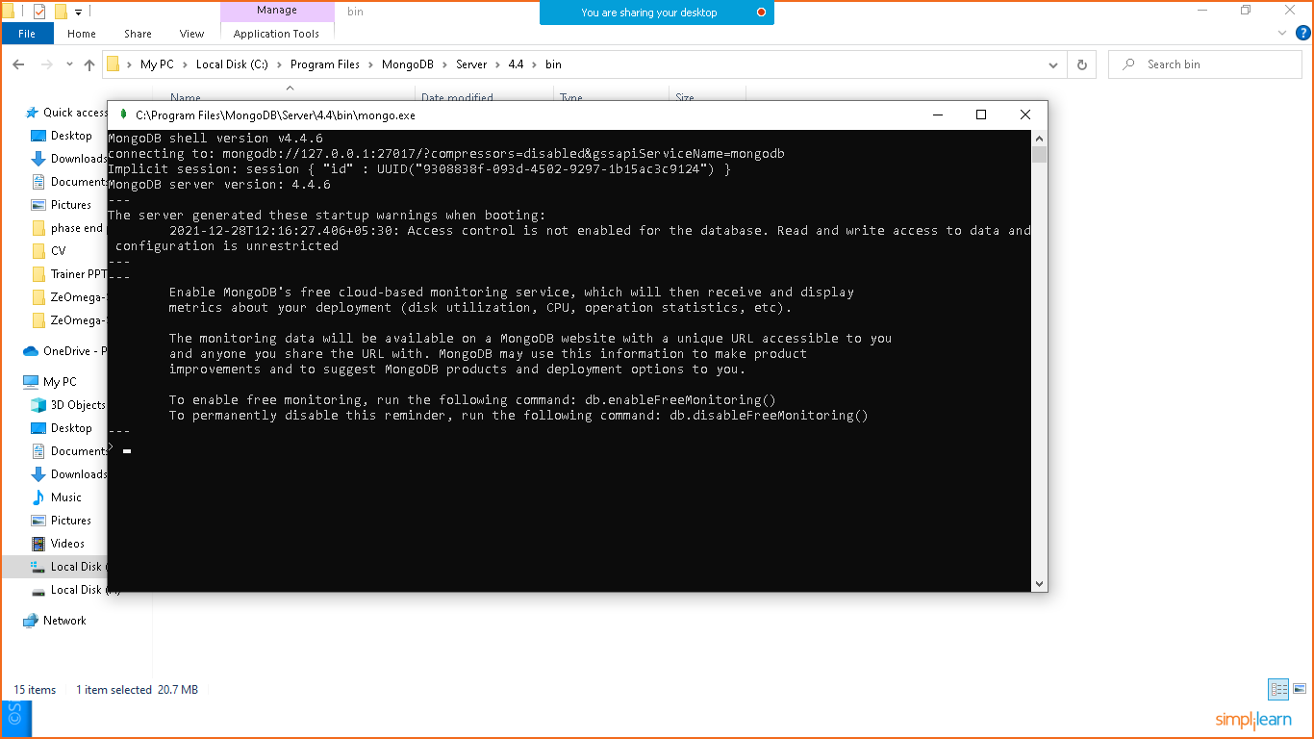

If you want to open mongo shell from cmd you can follow below steps

Open cmd

Execute mongo command

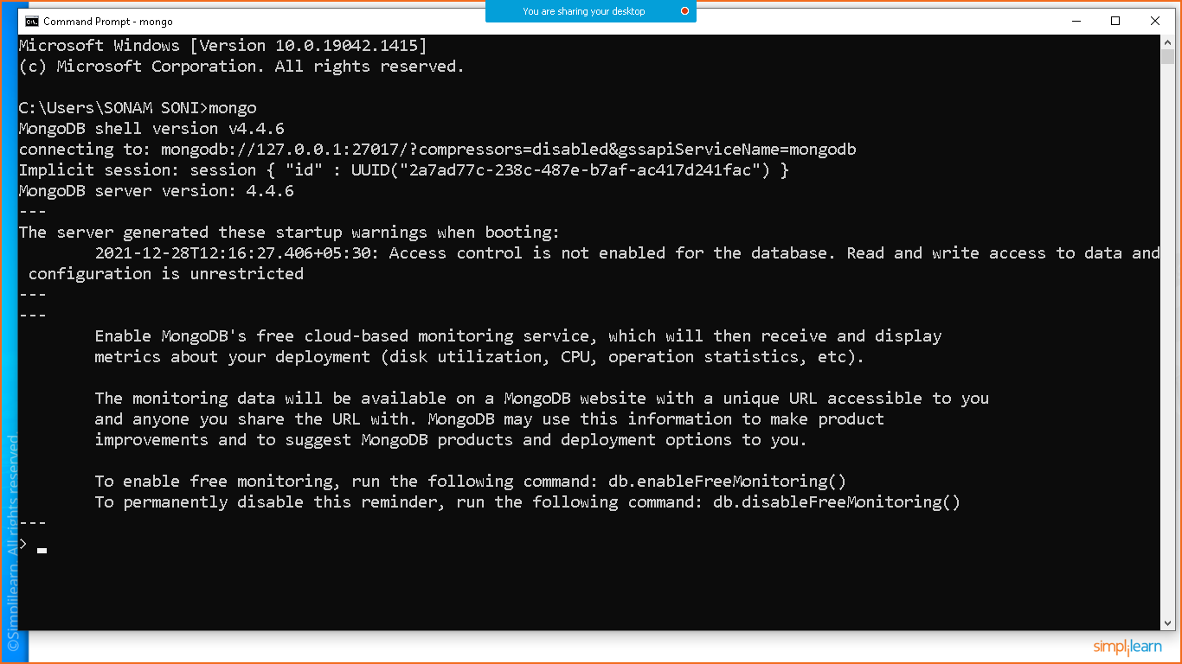

You can check list of databases using below command

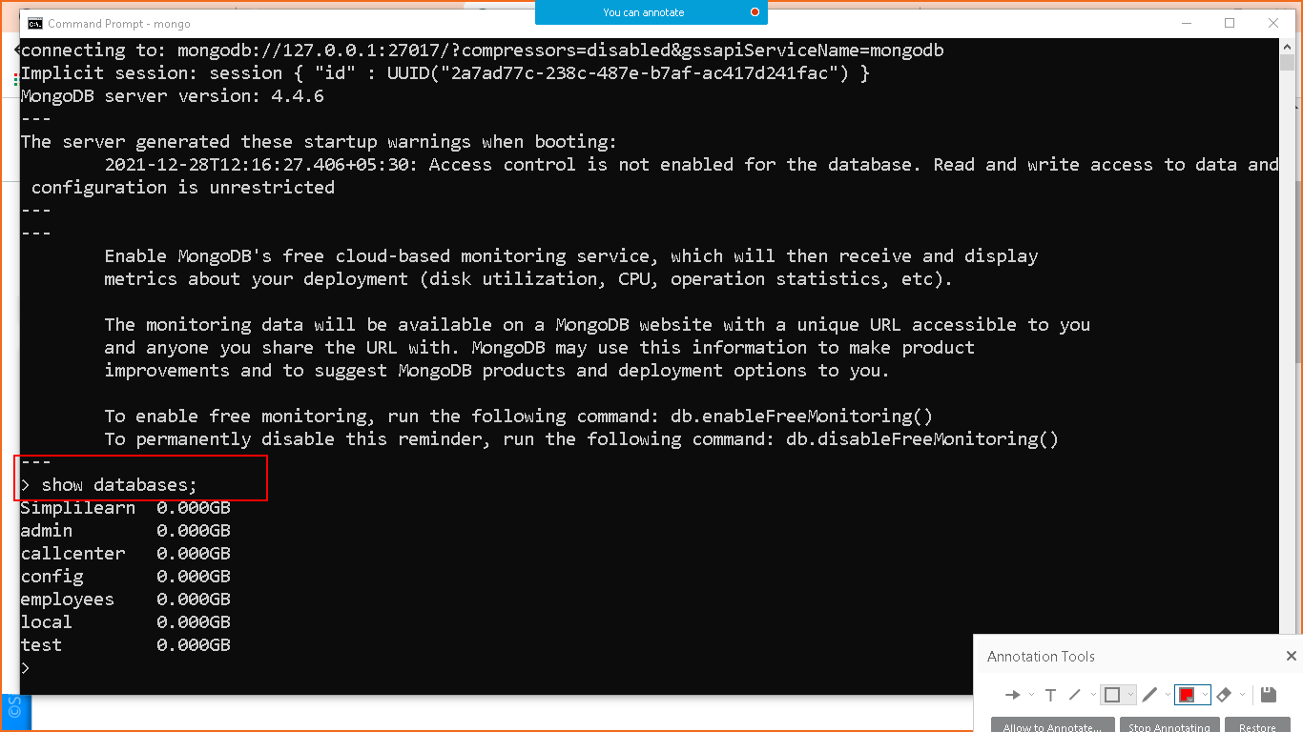

To use database

use database-name 🡪 use simplilearn;

To check list of collection

show collections;

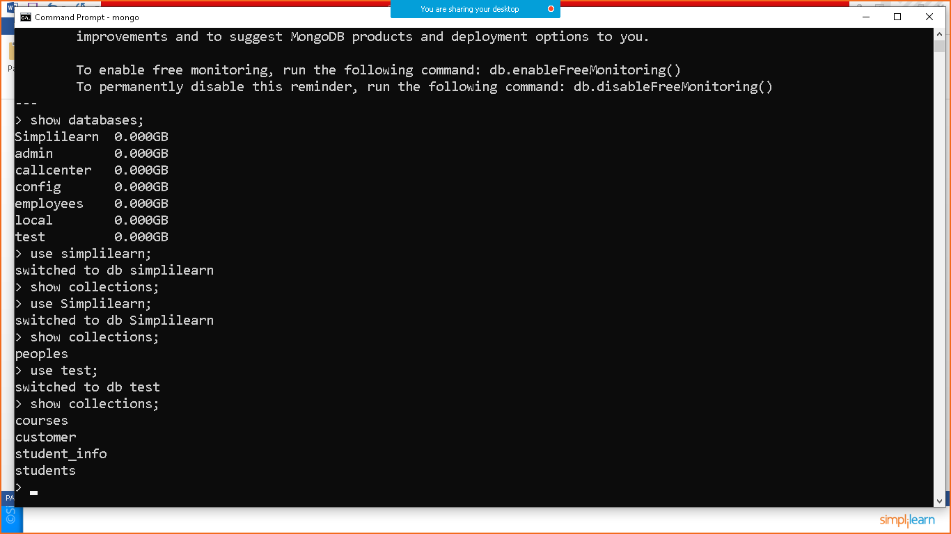

Setting up mongodb server

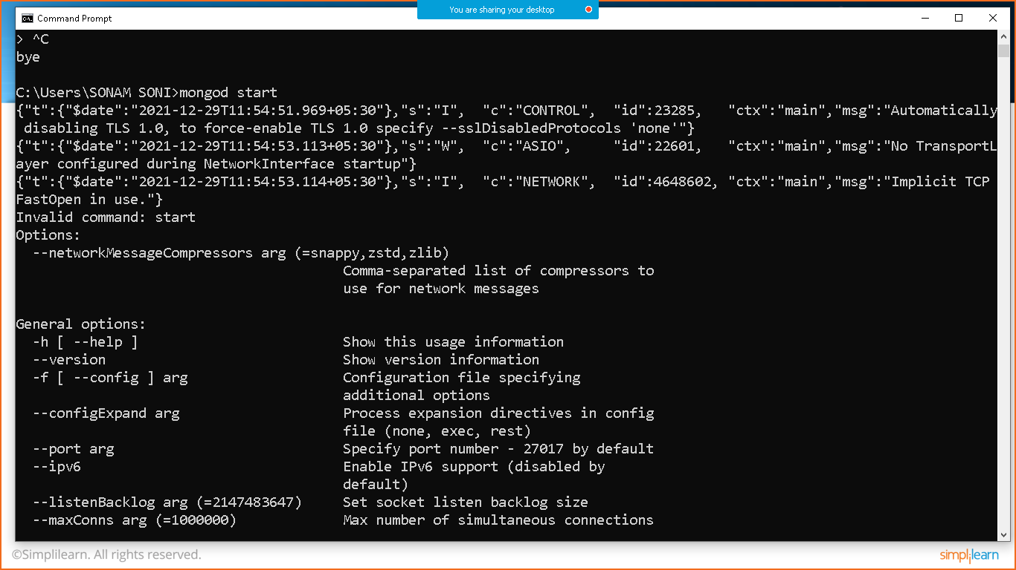

Execute mongod start

After start if you want to check status

Mongod status

To open mongo shell again execute

Mongo command

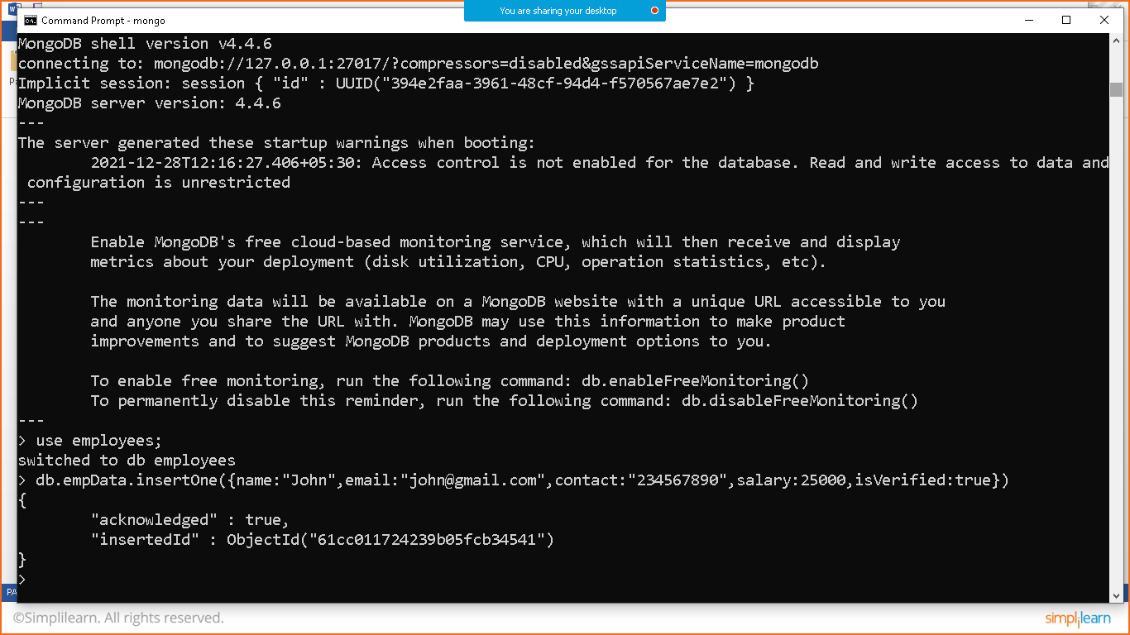

After executing this command

* Create database named employees
* Create collection named empData
* Insert record in json format with unique object Id

To check records

Db.collectionname.find();

To find all records from that collection

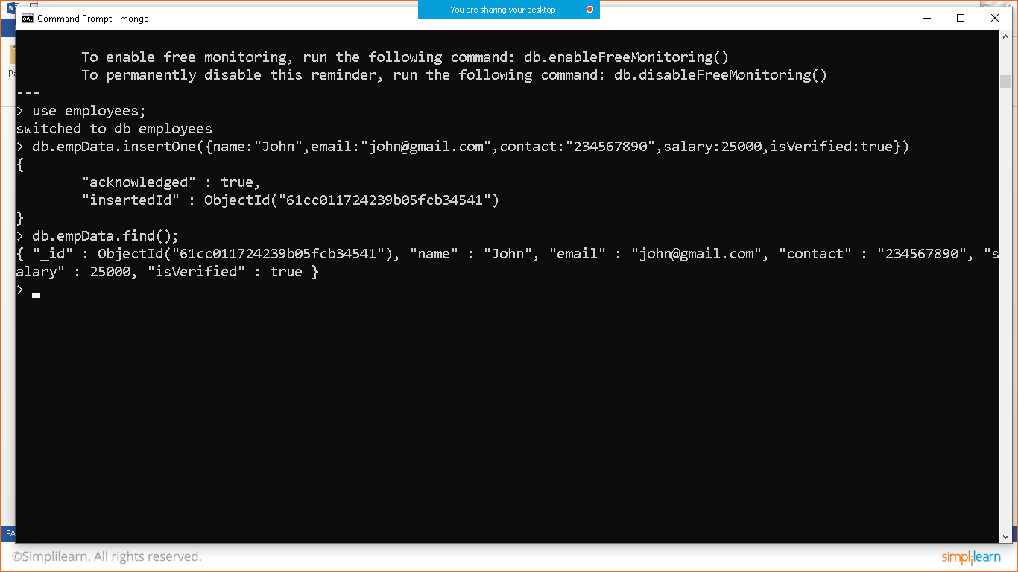

Call pretty() method to see data in proper format

